1. Introduction to Sound
The sound section is composed of circuitry which produces 4 types of sound, namely sounds 1,2,3 and 4, as specified below. The sound section can also synthesize and reproduce external patterns.

- Sound1: Produces quadrangular waves with sweep and envelope functions.
- Sound2: Produces quadrangular waves with an envelope.
- Sound3: Outputs voluntary wave patterns from Wave RAM.
- Sound4: Produces white noise with an envelope.

Each sound has two modes: ON and OFF.

1.1 ON MODE

According to the data set in the Mode register of each sound, the various sounds are produced. The data in the Mode register can be set at all times while producing sound.

1.2 INITIAL FLAG

When setting initial value of the envelope and restarting the length counter, set the initial flag at “1” and initialize the data.

1.3 MUTE

When the output level at sound 3 is set to mute (bits 5 and 6 of NR32=0), no sound will be produced regardless of the setting of the ON flag.

1.4 STOP

Under the following situations, the ON flag is reset and sound output stops:

- when the sound output is stopped by the length counter.
- when overflow occurs in the addition mode while the sweep is operating in Sound 1.

1.5 OFF MODE

During OFF mode, the operation of the frequency counter and the D/A converter stops, producing an interruption in sound output.

1.6 SOUND 3

When the sound OFF flag (bit 7 of NR30) is reset to “0”, cancellation of the OFF mode must be performed by setting the sound OFF flag to a “1”. This is performed by Sound 3.

1.7 ALL SOUND OFF MODE

When all the sound ON/OFF flags (bit 7 of NR52) are set to “0”, the mode registers for Sounds 1, 2, 3 and 4 are reset, and all sound output stops. To cancel this mode, set bit 7 of NR52 to “1”, then set all the sound ON/OFF flags to “1”.

(Note: The setting of each sound’s mode register must be done after the All Sound Off mode is cancelled. While this flag is set, sound mode registers cannot be set).

Chapter 2 Sound Control Register

2.1 SOUND MODE 1 REGISTER

Sound 1 is a circuit that produces a quadrangular wave pattern with sweep and envelope functions. It must be set at registers NR 10, NR 11, NR 12, NR 13, and NR 14.

NAME ADDRESS
NR10 FF10 key: is not used
w is read/write
is write only

D7 D6 D5 D4 D3 D2 D1 D0

Number of Sweep shifts (0-7)
Sweep increase/decrease
0: Addition (frequency increases)
1: Subtraction (frequency decrease)
Sweep Time

2.1.1 NUMBER OF SWEEP SHIFTS
The change of frequency (NR 13, NR14) at each shift is calculated by the following formula:

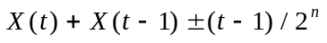
Where; X (0) = Initial Data
X (t-1) = Previous Frequency
n = 0~7

When calculating the above formula, if the value of a bit exceeds bit 11, the output of the sound stops, and the Sound 1 ON flag (at bit 0 of NR52) is reset. During the subtraction, when the value becomes less than 0, the value shown prior to the calculation will be the current value, thus making X (t) = X(t-1). However, when n=0, there will be no shift and the frequency remains unchanged.

2.1.2 SWEEP TIME ts
At each ts period, frequency changes.

000 : Sweep OFF
001 : ts = 1/f128 (7.8 ms)
010 : ts = 2/f128 (15.6 ms)
011 : ts = 3/f128 (23.4 ms)
100 : ts = 4/f128 (31.3 ms)
101 : ts = 5/f128 (39.1 ms)
110 : ts = 6/f128 (46.9 ms)
111 : ts = 7/128 (54.7 ms) f128 = 128Hz

Figure 2-2-1 Example, Sweep Wave Pattern

When NR10=79H and initial frequency data = 400H sweep wave pattern will be:

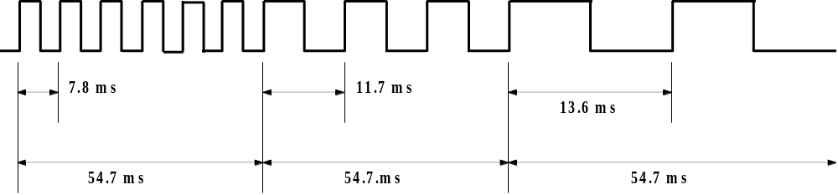

- Note: When the sweep function is not used, set the increase/decrease flag at “1” (subtract mode).

NAME ADDRESS
NR11 FF11

D7 D6 D5 D4 D3 D2 D1 D0

Sound Length Data (0 ~ 63)
Wave Pattern Duty

Sound Length = (64-t1) * (1/256) sec
Wave Duty

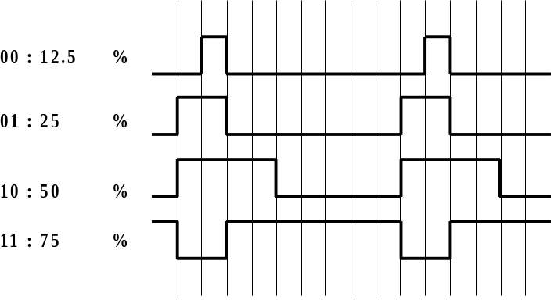

NAME ADDRESS
NR12 FF12

D7 D6 D5 D4 D3 D2 D1 D0

Number of Envelope Sweep (0 ~ 7)

Envelope UP/DOWN
0: Decrease
1: Range of Increase

Initial Value of Envelope

2.1.2.1 NUMBER OF ENVELOPE STEPS
set the range of increase or the length of a one-step decrease. The length of one-step = n * (1/64) sec. At n = 0, the envelope function stops.

2.1.2.2 INITIAL VALUE OF ENVELOPE (0000 - 1111)
Using the 4-bit D/A circuit, 16 levels of steps can be specified. It’s maximum level is 1111 and becomes mute at 0000.

Figure 2-2-2 Example, Initial Envelope Value

When NR12 = 94H,
Amp gain is:

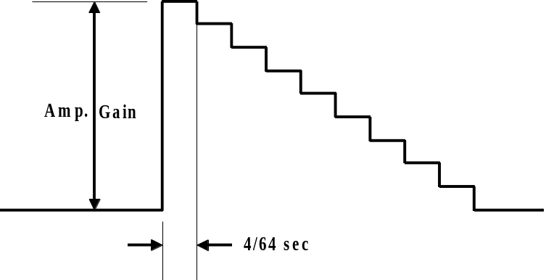

NAME ADDRESS
NR13 FF13

D7 D6 D5 D4 D3 D2 D1 D0
Frequency Data (Low) (all bits)

NAME ADDRESS
NR14 FF14

D7 D6 D5 D4 D3 D2 D1 D0

Frequency Data (High, 3 bit)
Counter/consecutive Selection
Initial

2.1.2.3 COUNTER/CONSECUTIVE SELECTION
When “0”, regardless of the length of data on the NR11 register, sound can be produced consecutively. When “1”, sound is generated during the time period set by the length data contained in register NR11. After the sound is ouput, the Sound 1 ON flag, at bit 0 of register NR52 is reset.

2.1.2.4 INITIAL
When this bit is set at “1”, Sound 1 starts again. Suppose the 11 bit frequency data set at NR13 and NR14 is X. Then the ouput frequency (f) can be calculated by the following formula.

Therefore, the minimum frequency will be 64Hz and the maximum frequency will be 131.1Khz.

2.1.3 CAUTIONS WHEN USING SOUND 1

- When the sweep function is not used at Sound 1, set the sweep time at 0 (sweep OFF) and either set the sweep increase/decrease flag at 1 or the sweep shift number at 0. (Set NR10 at 04H ~ 07H or 00H.)

- If the sweep increase/decrease flag of NR10 is set at 0 (addition mode), the sweep shift number may be anything other than 0, and the sweep OFF mode is set (e.g., NR10=01H), there are cases in which no sound is produced.

- When changing the content of the envelope register (NR12) while the sound is operating (i.e., when the ON flag is at 1), set the value at the envelope register before setting the initial flag.

2.2 SOUND 2 MODE REGISTER

Sound 2 is a circuit that produces a quadrangular wave pattern with an envelope function. It can be set at registers NR21, NR22, NR23, and NR24.

NAME ADDRESS
NR21 FF16

D7 D6 D5 D4 D3 D2 D1 D0

Sound Length Data (0 ~ 63)
Wave Pattern Duty

NAME ADDRESS
NR22 FF17

D7 D6 D5 D4 D3 D2 D1 D0

Number of Envelope Sweeps ( 0 ~ 7)
Envelope UP/DOWN
0: Decrease
1: Range of Increase
Initial Value of Envelope

NAME ADDRESS
NR23 FF18

D7 D6 D5 D4 D3 D2 D1 D0
Frequency Data (Low) (all bits)

NAME ADDRESS
NR24 FF19

D7 D6 D5 D4 D3 D2 D1 D0

Frequency Data (High, 3 bit)
Counter/consecutive Selection
Initial

2.2.1 COUNTER/CONSECUTIVE SELECTION

When “0”, regardless of the length data on the NR21 register, sound is produced consecutively. When “1”, sound is generated for the time period set by the length data contained in register NR21. After the sound is ouput, The Sound 2 ON Flag (bit 1) of register NR52 is reset.

2.2.2 INITIAL

When this bit is set at “1”, Sound 2 starts again.

2.2.3 CAUTIONS WHEN USING SOUND 2

When changing the content of the envelope register (NR22) while the sound is operating (i.e., when the ON flag is at 1), set the value at the envelope register before setting the initial flag.

2.3 SOUND 3 MODE REGISTER

Sound 3 is a circuit which produces a voluntary wave pattern. It automatically reads the wave pattern (one cycle) written on addresses FF30H ~ FF3FH of a Wave Pattern RAM. This wave pattern can be output while changing the length, frequency, and sound level using registers NR30, NR31, NR32, NR33, and NR34. Assignment of sound length, frequency function are similar to the Sound 1 circuit.

NAME ADDRESS
NR30 FF1A

D7 D6 D5 D4 D3 D2 D1 D0

Sound OFF
0: Sound 3 Output Stop
1: Sound 3 Output OK

NAME ADDRESS
NR31 FF1B

R/W Select the Sound Length

D7 D6 D5 D4 D3 D2 D1 D0
Sound Length Data (t1) (all bits)
Sound Length = (256-t1) * (1/256) sec

NAME ADDRESS
NR32 FF1C

D7 D6 D5 D4 D3 D2 D1 D0

Select Output Level

Output level:
00 : Mute
01 : Produce the wave pattern RAM data as it is (4-bit length).
10 : Produce the wave pattern RAM data (4-bit length) at the one-bit right shift (1/2) form.
11 : Produce the wave pattern RAM data (4-bit length) at the 2-bit right shift (1/4) form.

NAME ADDRESS
NR33 FF1D

D7 D6 D5 D4 D3 D2 D1 D0

Frequency (Low) (all bits)

NAME ADDRESS
NR34 FF1E

D7 D6 D5 D4 D3 D2 D1 D0

Frequency Data (High, 3 bit)
Counter/consecutive Selection
Initial Flag

2.3.1 COUNTER/CONSECUTIVE SELECTION

When this bit is set to “0”, sound is produced consecutively, regardless of the length data on the NR31 register. When set to “1”, sound is generated for the length of time set by the length data contained in register NR31. After the sound is output, the ON flag of Sound 3, bit 2 of register NR52, is reset.

2.3.2 INITIAL FLAG

When the sound OFF flag (NR30, bit 7) is at “1”, and a “1” is assigned to bit 7 of NR34, Sound 3 starts again.

2.3.3 PROGRAMMING CAUTIONS

When changing frequency while outputting Sound 3, the Initial flag must not be set. This may cause data in the Wave RAM to be destroyed.

The initial flag may be set during the ouput of Sound 1, 2, and 4.

WAVE RAM FORMAT
ADDRESS | D7 | D6 D5 | D4 | D3 | D2 D1 | D0
FF30 |  | Step 0 |  |  | Step 1
FF31 |  | Step 2 |  |  | Step 3
FF32 |  | Step 4 |  |  | Step 5
....all the way down to:

FF3F |  | Step 30 |  |  | Step 31

[EXAMPLE] CHOPPING WAVE
FF30H - 01H, 23H, 45H, 67H
89H, ABH, CDH, EFH
EDH, CBH, A9H, 87H
65H, 43H, 21H, 00H

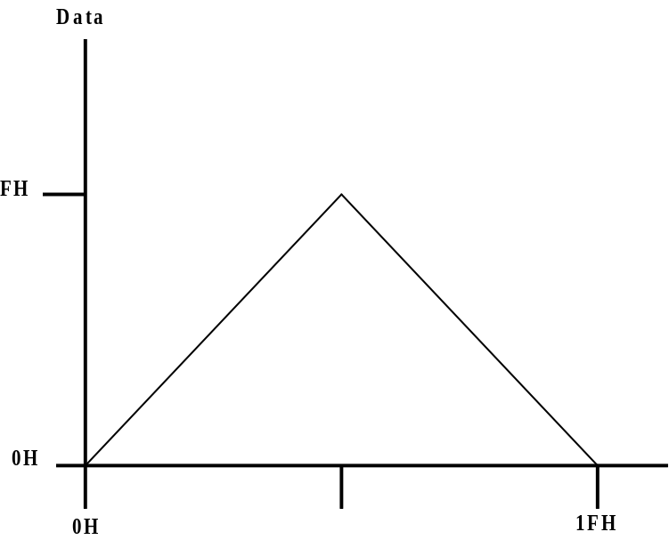

2.4 SOUND 4 MODE REGISTER

Sound 4 is a circuit that produces white noise. It’s output data is produced by switching the step of the polynomial counter that produces frequencies and random numbers. This is performed by changing the frequency ratio and envelope data using registers NR41, NR42, and NR44.

NAME ADDRESS
NR41 FF20

R/W Select the Sound Length

D7 D6 D5 D4 D3 D2 D1 D0

Sound Length Data t1 (0 ~ 63)

NAME ADDRESS
NR42 FF21

D7 D6 D5 D4 D3 D2 D1 D0

Number of Envelope Steps (0 ~ 7)

Envelope Up/Down
0: Decrease
1: Range of Increase

Initial Value of Envelope

NAME ADDRESS
NR43 FF22

D7 D6 D5 D4 D3 D2 D1 D0

Selection of Frequency Ratio
Selection of Polynomial Counter’s Step
Selection of the Shift Clock Frequency
for the Polynomial Counter

2.4.1 SELECTION OF FREQUENCY RATIO

The polynomial counter’s shift clock is comprised of a 14-step pre-scaler. Select the imput clock of the pre-scaler, as follows:

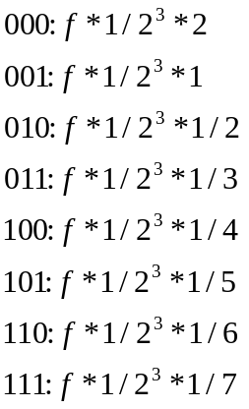

2.4.2 SELECTION OF POLYNOMIAL COUNTER STEP
0: 15 steps
1: 7 steps

2.4.3 SELECTIONS OF POLYNOMIAL COUNTER CLOCK

0000: Ratio of Frequencies * 1/2
0001: Ratio of Frequencies * 1/2
0010: Ratio of Frequencies * 1/2
0011: Ratio of Frequencies * 1/2
•••• ••••
1101: Ratio of Frequencies *1/2
1110: Not Used
1111: Not Used

NAME ADDRESS (F.H Note: The Name and Address for this register are written verbatim, but most
NR30 FF1A likely it should read, “Name NR44 : Address FF23”)

D7 D6 D5 D4 D3 D2 D1 D0

Counter/consecutive Selection
Initial

2.4.4 COUNTER/CONSECUTIVE SELECTION

Regardless of the length on the NR41 register, sound is produced consecutively while this bit is “0”. When bit 6 is set to “1”, sound is generated for the time period set by the length data contained in register NR41. After the sound is ouput, the ON flag of Sound 4 (bit 3 of register NR52) is reset.

2.4.5 INITIAL

When bit 7 is “1”, Sound 4 starts again.

2.4.6 PROGRAMMING CAUTIONS

When changing the content of the envelope register (NR22) while the sound is operating (ON flag at “1”), set the value at the envelope register before setting the Initial flag.

2.5 SOUND CONTROL REGISTER

NAME ADDRESS
NR50 FF24

D7 D6 D5 D4 D3 D2 D1 D0

S01 Output Level (0 ~ 7)
000: Minimum Level (≤ +8)
111: Maximum Level
Vin → SO1 ON/OFF
SO2 Output Level (0 ~ 7)
000: Minimum Level (≤+8)
111: Maximum Level
Vin → SO2 ON/OFF

Vin → SO1 (Vin → SO2)
The voice input for a Vin terminal is produced by synthesizing the combined sound from Sounds 1 through 4.
0: No Output
1: Output OK

NAME ADDRESS
NR51 FF25

D7 D6 D5 D4 D3 D2 D1 D0
(0: No Output 1: Output OK)
Output Sound 1 to SO1 Terminal
Output Sound 2 to SO1 Terminal
Output Sound 3 to SO1 Terminal
Output Sound 4 to SO1 Terminal
Output Sound 1 to SO2 Terminal
Output Sound 2 to SO2 Terminal
Output Sound 3 to SO2 Terminal
Output Sound 4 to SO2 Terminal

NAME ADDRESS
NR52 FF26

D7 D6 D5 D4 D3 D2 D1 D0

Sound 1 ON Flag
Sound 2 ON Flag
Sound 3 ON Flag
Sound 4 ON Flag
Each sound is set during its output. It is
reset at the counter mode after the time
set by the length data elapses.
All sound ON/OFF
0: Stop all sound circuits
1: Operate all sound circuits

***************************************************************************
Credits:
Game Boy Sound Document (version 1.2) was brought to you by NoComply, F.H.
Document Reproduced by F.H.
****************************************************************************

